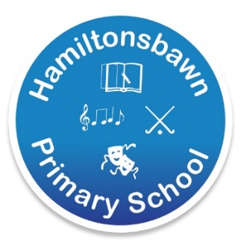 | 113 Annareagh Road  Hamiltonsbawn  Principal: Mr D R Hutchinson Co Armagh  Telephone: 028 38870628 BT61 9SA  Email:info@hamiltonsbawnps.hamiltonsbawn.ni.sch.uk  Website: www.hamiltonsbawnps.com

Supporting Children of Key Workers in Primary School
Dear Parents
We have received some clarification on the position of schools on Monday.
We have been asked to facilitate pupils in school whose parents are Key Workers and critical to the Covid-19 team response.
This facility is only available to those Key Workers in the list below who would otherwise have no option but to stay at home to ensure safe supervision of their children. The ultimate aim remains to keep the number of children in school to an absolute minimum to limit the spread of the COVID-19 virus. Places will be facilitated for pupils with both parents working as key workers who have exhausted all other child care options. Children should only be in school during parents working hours. The following headings define the term ‘Key Worker’ as provided by The Department of Education:
- Health and Social Care: doctors, nurses, midwives, paramedics, social workers and home carers.
- Education and Childcare: education professionals who remain active during Covid-19 response.
- Public Safety and National Security: police, fire and rescue, prison.
- Those keeping air, water, road and rail transport modes operating.
- Utilities: staff needed for oil, gas, electricity and water and key staff in telecommunications, post and waste disposal.
- Food production and processing, distribution and those essential to the provision of key goods (e.g. hygiene, medical).
- Key national and local government.
- For full details go to: www.education-ni.gov.uk
If you are a Key Worker and need to send your child to school we would ask you to apply by email to dhutchinson705@c2kni.net with the following information by 12pm Saturday 21st March.
- Child’s Name and class
- Parent/Guardian(s) name and detail of employment (role & employer)
- Emergency contact number
- Specify Hot dinner or Packed Lunch - Free school meals yes/no
- Dates of Care required 23rd-27th March
School will be open from 9am to 3pm, children are not required to wear school uniform as this will be a child care scenario. They should bring their education pack as provided by their teacher. No other toys or devices are permitted to be brought from home for infection control reasons. Children will likely be located in the school hall rather than classrooms to respect the guidance on social distancing. Lunch, we are advised, will be via packed lunch or a delivered hot school meal.
Before contacting school, please consider that we will not be able to operate a ‘normal’ school day. We will aim to practice social distancing and good hygiene in school which will be quite a challenge as you can imagine. Remember DO NOT send your child to school if:
- they are unwell
- if any member of the family is unwell or isolating according to NHS guidelines
- if any member of the family is in the ‘vulnerable’ to infection category.
Please note that these plans are subject to review and change at short notice in this very fast moving situation. We will keep you informed of any changes via Facebook, MySchool Text and the School Website.
We will do our absolute best to support key workers because your role is critical in the fight against Covid-19. We will look after your children in order to support you in your very important role.
Stay safe everyone.
Regards
Mr. D Hutchinson

